**NATIONAL TSING HUA UNIVERSITY**

**DEPARTMENT OF COMPUTER SCIENCE**

## CS 4100: Computer Architecture

# Spring 2018, Mid-term Examination

1. (16%) Consider a program running on a 1-GHz processor with the following measurements:

|  |  |  |
| --- | --- | --- |
| Instruction type | Execution cycle | Number of instructions |
| Arithmetic and logic | 2 | 500,000 |
| Load/store | 4 | 300,000 |
| Branch/jump | 3 | 200,000 |
| Others | 2 | 100,000 |

* + 1. What is the execution time of the program on the processor? (List the equation only.)
    2. What is the average CPI of the program? (List the equation only.)
    3. Noob Use the single-cycle implementation of the MIPS processor to explain why CPU performance has to consider both CPI and cycle time.
    4. ??Explain why CPI is affected by computer architecture.

1. Noob (20%) Consider the following code segment, which loads x[i][j] to $t7, where 0 ≤ i, j < n.

**add $s4, $zero, $zero # i = 0**

**loop_i: add $s5, $zero, $zero # j = 0**

**loop_j: mult $s4, $s1 # i * n**

**mflo $t0**

**add $t1, $t0, $s5 # i * n + j**

**sll $t1, $t1, 2**

**add $t2, $t1, $s0 # address of x[i][j]**

**lw $t7, 0($t2) # t7 🡨 x[i][j]**

…

* + 1. Why do we need the instruction, **mflo $t0**, after the instruction, **mult $s4, $s1**?
    2. What is the content of **$s0**?
    3. Modify the code so that we do not need to use **mult**, **mflo**, and **sll**. Give comments to each instruction you write.

1. (5%) Suppose the instruction “beq $1,$2,-3” is stored at location 0x35ED2930. What is the target address if the branch is taken?
2. (5%) What is the IEEE 754 representation of -1/3?
3. (15%) Complete the steps of the unsigned division shown below.

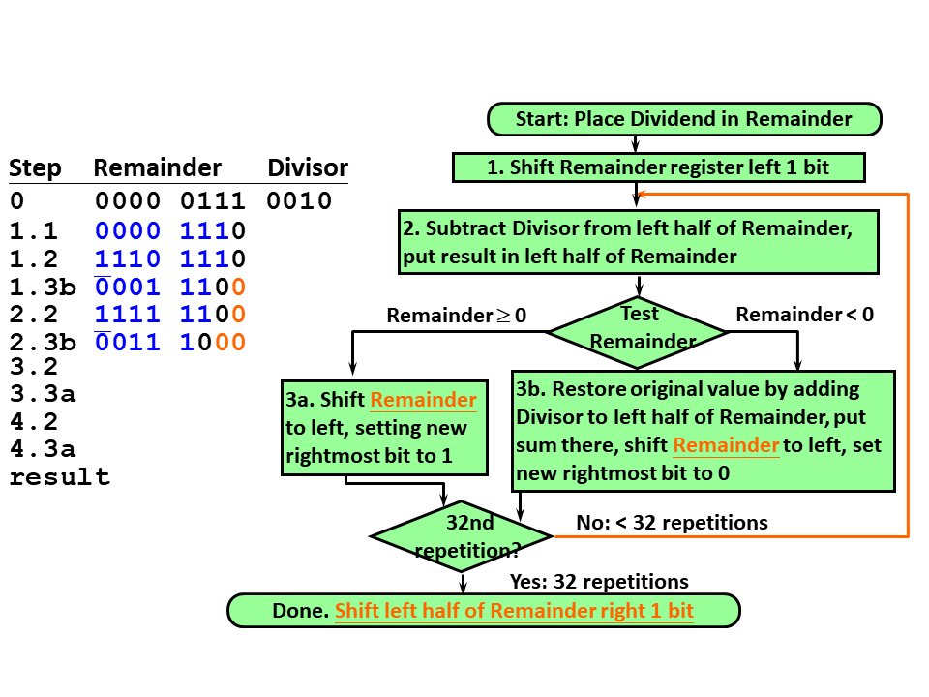

1. (10%) The 32-bit ALU introduced in Chapter 3 supports and, or, add, sub, set-on-less, and nor operations. Which operation takes the longest time to complete in the worst case? Explain why.
2. (9%) Suppose a program consists of a sequential part and a fully parallelizable big loop running N iterations. On a single processor, the sequential part takes 10% of the total execution time T and the big loop takes 90%. According to the Amdahl’s Law, the speedup that the program can get by parallel computers is at most 10. One way to get more speedup is to ask the program to run more iterations in the big loop. How many iterations does the big loop need to run in order to get a maximum speedup of 20? List your equation to explain how you get the answer.
3. (20%) Consider the single-cycle implementation of the MIPS processor shown below.
   * 1. Which components act as the storage elements during the execution of sw? Explain your answers.
     2. What is the purpose of the MUX next to the “write register” input of the register file?
     3. Which instruction determines the cycle time of this implementation? Explain your answer.
     4. By observing the figure, which control signals from “Control” should be set to 1 so that a beq instruction can be executed correctly? (Note: ALUop is 01 for beq)

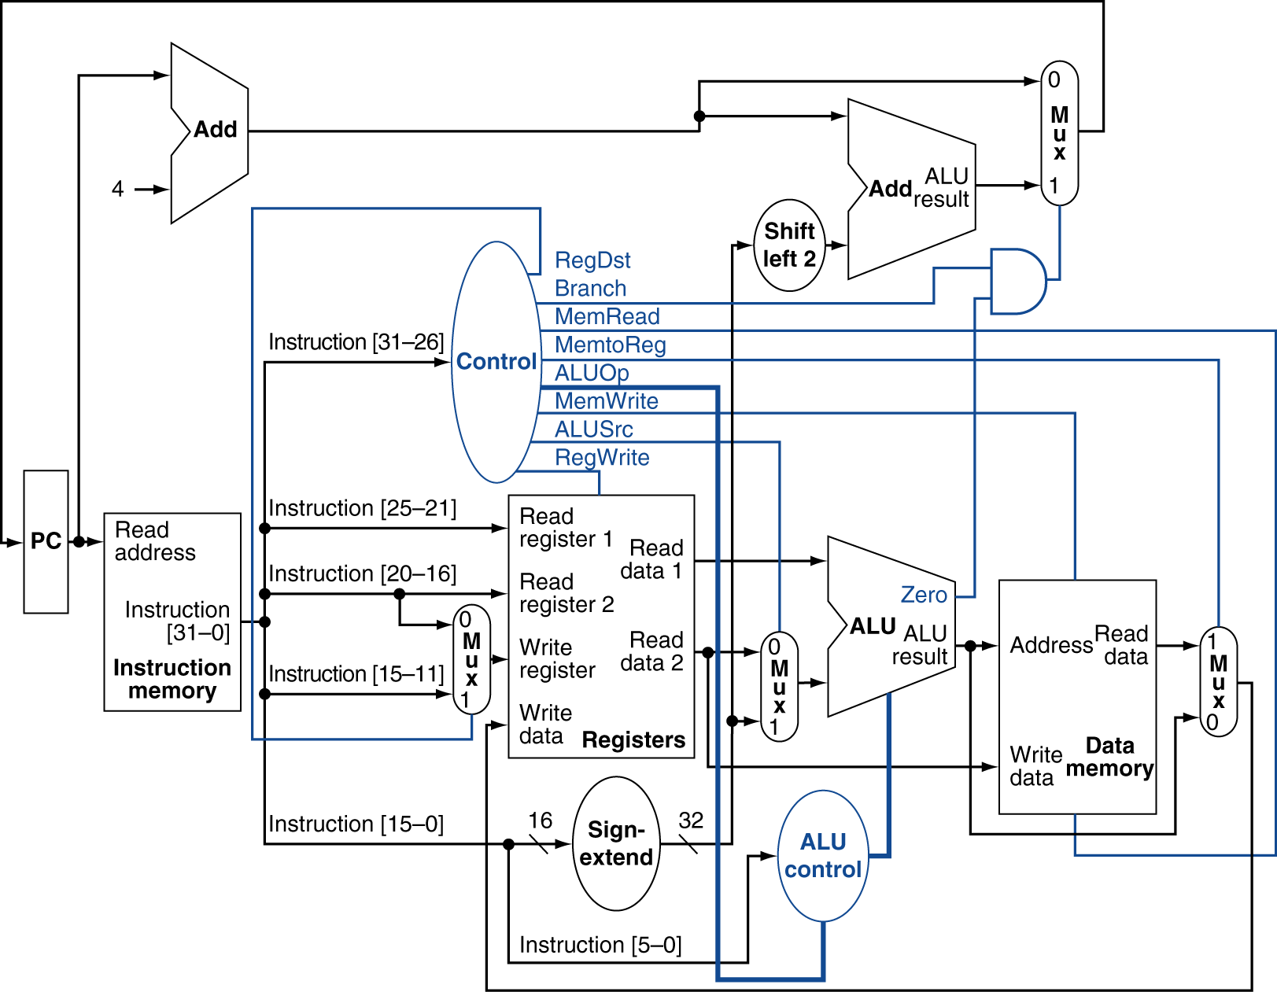

Figure 2

Figure 1